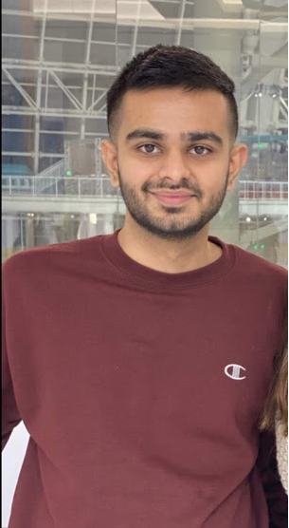

***Inspirational Teacher***

I grew up in India and did my primary schooling there. I am very fortunate to have been around some of the amazing teachers that have helped me shape my life. Whoever I am right now is because of the teachers and the things they taught me. My 6th grade teacher Mr. Joshi has been so far my favorite and most inspiring. He was the PT teacher and the passion I have for soccer is because of him. I am still in touch with him on social media and talk to him now and then. He pushed me to my limits and inspired me to become a better version of myself.

***Self-improvement***

As mentioned in previous section, despite of winning competitions in writing, I think my writing abilities can be improved. I have never considered writing as my strength but have done pretty decent in it. I would like to do even better, and this class will help me do so. Another thing I would like to work on is when to quit or move on. Sometimes I will get stuck at something that isn’t very important, but I will do everything to finish it and will not stop until I do so. I need to learn how to prioritize things and how to manage tasks wisely.

***Strengths***

I work as a Software Developer and I consider myself a good coder, although I still have a lot to learn. As far as this class is concerned, I think my writing skills are decent but can be better. I have had the opportunity in high school to write speeches for various occasions. I have also participated in various essay writing competitions as a kid and have won many of those. I consider myself a hard worker and someone who will not give up easily. Learning new things and reading is very important to me and I consider it my strength as I am very consistent with it.

***About me***

Hello, my name is Himesh. I live in Somerset, New Jersey. I am a transfer student from County College of Morris and now, a senior at Rutgers. Working as a Software Engineer since my sophomore year has been very challenging and has helped me grow as a person. Working, along with taking a comprehensive Computer Science and Statistics course has not been easy, but I had fun doing everything at once. I love to play soccer, swim, go on hikes, and hang out with friends and family. In the future, I would like to be a data scientist as everything about it interests me a lot.

***Hopes for class***

I am hoping to learn more about writing, teamwork, and critical thinking skills which will help me in future as well. This class will help me develop professional writing skills which is very important for everyone, as nowadays most of the conversation happen via email in office environment. We were taught English from 3rd grade in school in India. My father has been a big reason for my love for this language, as in India, not a lot of people converse in English. My father would always make me read English news papers and books as he believed that it is essential for everyone to learn this language. The assignments for this class also seem very interesting, and I am excited about it!